UNIVERSITY OF MUMBAI

INSTITUTE OF DISTANCE AND OPEN LEARNING (IDOL)

PRACTICAL JOURNAL IN PAPER - I

RESEARCH IN COMPUTING SUBMITTED BY
PRAMOD R. SHARMA
APPLICATION ID :6647
SEAT NO:508144

MASTERS OF SCIENCE IN INFORMATION TECHNOLOGY PART-1 SEMESTER-1

ACADEMIC YEAR 2022-2023

INSTITUTE OF DISTANCE AND OPEN LEARNING IDOL BUILDING, VIDYANAGRI, SANTACRUZ(EAST), MUMBAI-400 098

CONDUCTED AT
RIZVI COLLEGE OF ARTS, SCIENCE AND COMMERCE BANDRA(W), MUMBAI- 400050

UNIVERSITY OF MUMBAI

INSTITUTE OF DISTANCE AND OPEN LEARNING (IDOL)

Dr. Shankar Dayal Sharma Bhavan, Kalina Vidyanagri, Santacruz(E), Mumbai-400 098

Certificate

This is to certify that

Mr. Pramod Radheshyam Sharma, Application ID: 6647, Seat No: 508144 - from Rizvi College of Arts, Science and Commerce Bandra(W), Mumbai 400 050 has successfully completed practical Paper I titled RESEARCH IN COMPUTING for M.sc (IT) Part1 semester 1 in the academic year 2022-2023.

M.sc (IT) Co-Ordinator, IDOL External Examiner

INDEX

Sr.  No | Practical Aim | Signature
1 | - Write a program for obtaining descriptive statistics of data.  - Import data from different data sources (from Excel, csv, mysql, sql server, oracle to R/Python/Excel)
2 | - Design a survey form for a given case study, collect the  primary data and analyze it  - Perform suitable analysis of given secondary data.
3 | - Perform testing of hypothesis using one sample t-test.  - Perform testing of hypothesis using two sample t-test.  - Perform testing of hypothesis using paired t- test.
4 | - Perform testing of hypothesis using chi- squared goodness-  of-fit test.  - Perform testing of hypothesis using chi- squared Test of Independence
5 | a. Perform testing of hypothesis using Z-test.
6 | - Perform testing of hypothesis using one-way ANOVA.  - Perform testing of hypothesis using two-way ANOVA  - Perform testing of hypothesis using multivariate ANOVA (MANOVA).
7 | - Perform the Random sampling for the givendata and analyse  it.  - Perform the Stratified sampling for the givendata and  analyse it.
8 | a. Compute different types of correlation.
9 | - Perform linear regression for prediction.  - Perform polynomial regression for prediction.
10 | - Perform multiple linear regression.  - Perform Logistic regression.

Practical 1

- Write a program for obtaining descriptive statistics of data. ################################################################ #Practical 1A: Write a python program on descriptive statistics analysis. ################################################################import pandas as pd
#Create a Dictionary of series
d = {'Age':pd.Series([25,26,25,23,30,29,23,34,40,30,51,46]), 'Rating':pd.Series([4.23,3.24,3.98,2.56,3.20,4.6,3.8,3.78,2.98,4.80,4.10,3.65])}
#Create a DataFrame df = pd.DataFrame(d)print(df) print('############ Sum ########## ')
print (df.sum())
print('############ Mean ########## ')
print (df.mean())
print('############ Standard Deviation ########## ')print (df.std())
print('############ Descriptive Statistics ########## ')print (df.describe())

Output:
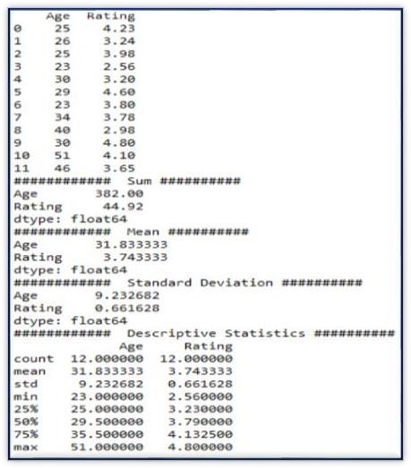

Using Excel

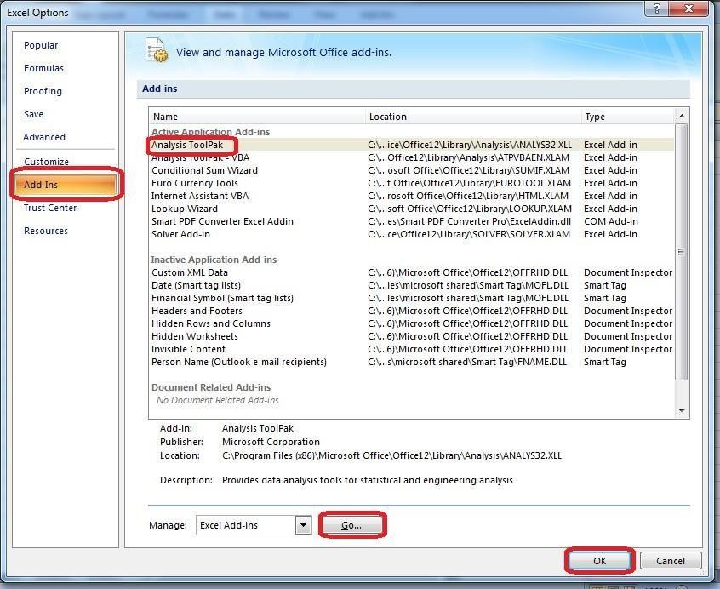

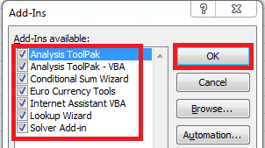

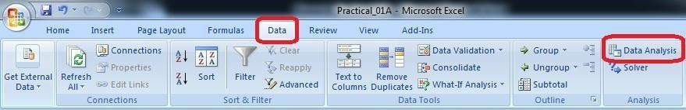

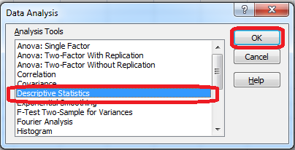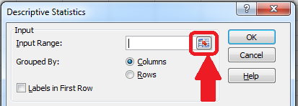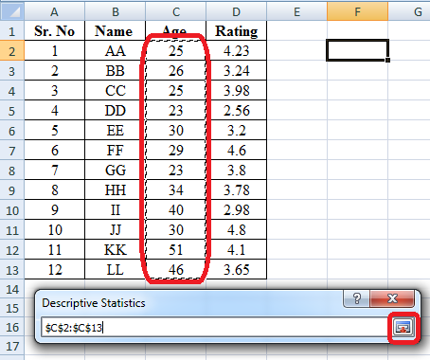

\

Select the data range from the excel worksheet.

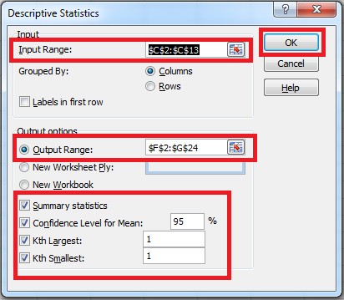

Output:

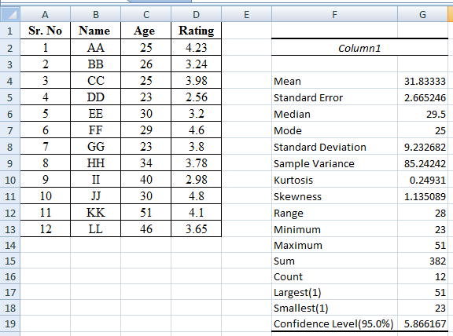

- Import data from different data sources (from Excel, csv, mysql, sqlserver, oracle to R/Python/Excel)

SQLite:
import sqlite3 as sqimport pandas as pd
################################################################ Base='C:/VKHCG'
sDatabaseName=Base + '/01-Vermeulen/00-RawData/SQLite/vermeulen.db' conn = sq.connect(sDatabaseName) ################################################################
sFileName='C:/VKHCG/01-Vermeulen/01-Retrieve/01-EDS/02- Python/Retrieve_IP_DATA.csv'
print('Loading :',sFileName) IP_DATA_ALL_FIX=pd.read_csv(sFileName,header=0,low_memory=False) IP_DATA_ALL_FIX.index.names = ['RowIDCSV'] sTable='IP_DATA_ALL' print('Storing :',sDatabaseName,' Table:',sTable) IP_DATA_ALL_FIX.to_sql(sTable, conn, if_exists="replace") print('Loading
:',sDatabaseName,' Table:',sTable) TestData=pd.read_sql_query("select * from IP_DATA_ALL;", conn)print('################')
print('## Data Values') print('################')
print(TestData) print('################')
print('## Data Profile') print('################')
print('Rows :',TestData.shape[0]) print('Columns :',TestData.shape[1]) print('################')
print('### Done!! ############################################')

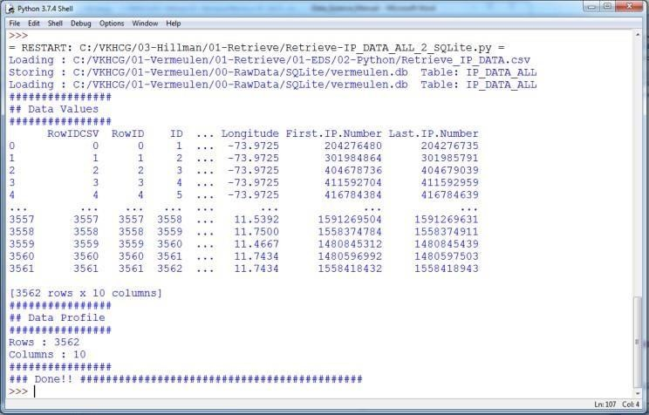

MySQL:
Open MySql
Create a database ―DataScience‖
Create a python file and add the following code:
################ Connection With MySQL ######################
importmysql.connector

conn = mysql.connector.connect(host='localhost', database='DataScience',
user='root', password='root') conn.connect if(conn.is_connected):
print('###### Connection With MySql Established Successfullly ##### ')else: print('Not Connected -- Check Connection Properites')

Microsoft Excel
##################Retrieve-Country-Currency.py # -*- coding: utf-8 -*-
importos
import pandas as pd Base='C:/VKHCG'
sFileDir=Base + '/01-Vermeulen/01-Retrieve/01-EDS/02-Python'#if not os.path.exists(sFileDir):

#os.makedirs(sFileDir)
CurrencyRawData = pd.read_excel('C:/VKHCG/01-Vermeulen/00-RawData/Country_Currency.xlsx')sColumns
= ['Country or territory', 'Currency', 'ISO-4217'] CurrencyData = CurrencyRawData[sColumns]
CurrencyData.rename(columns={'Country or territory': 'Country', 'ISO-4217': 'CurrencyCode'}, inplace=True) CurrencyData.dropna(subset=['Currency'],inplace=True) CurrencyData['Country'] = CurrencyData['Country'].map(lambda x: x.strip()) CurrencyData['Currency'] = CurrencyData['Currency'].map(lambda x: x.strip()) CurrencyData['CurrencyCode'] = CurrencyData['CurrencyCode'].map(lambda x:x.strip()) print(CurrencyData)
print('~~~~~~ Data from Excel Sheet Retrived Successfully ~~~~~~~ ')sFileName=sFileDir + '/Retrieve-Country-Currency.csv' CurrencyData.to_csv(sFileName, index = False)

OUTPUT:

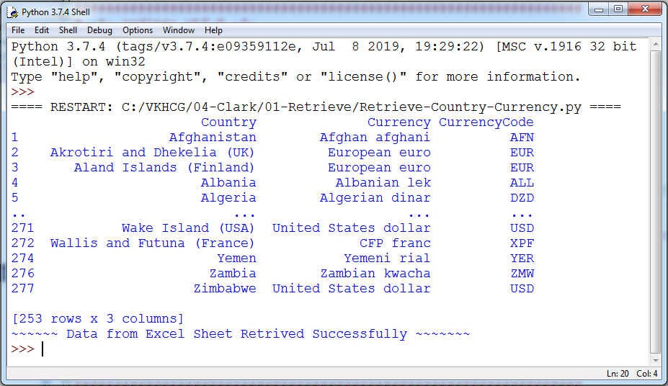

Practical 2

Perform analysis of given secondary data.
  - Determine your research question – Knowing exactly what you are looking for.
  - Locating data– Knowing what is out there and whether you can gain access to it. A quick Internet search, possibly with the help of a librarian, will reveal a wealth of options.
  - Evaluating relevance of the data – Considering things like the data‘s original purpose, when it was collected, population, sampling strategy/sample, data collection protocols, operationalization of concepts, questions asked, and form/shape of the data.
  - Assessing credibility of the data – Establishing the credentials of the original researchers, searching for full explication of methods including any problems encountered, determining how consistent the data is with data from other sources, anddiscovering whether the data has been used in any credible published research.
  - Analysis – This will generally involve a range of statistical processes.

Example:Analyze the given Population Census Data for Planning and Decision Making byusing the size and composition of populations.

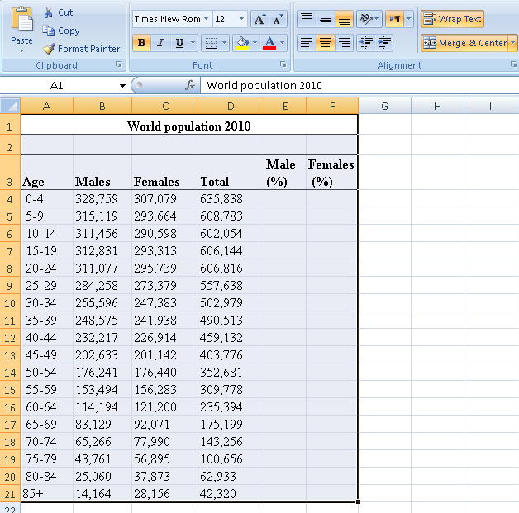

Put the cursor in cell B22 and click on the AutoSum and then click Enter. This will calculatethe total population. Then copy the formula in cell D22 across the row 22.To calculate the percent of males in cell E4, enter the formula =-1*100*B4/$D$22 . And copy the formula in cell E4 down to cell E21.
To calculate the percent of females in cell F4, enter the formula =100*C4/$D$22. Copy the formula in cell F4 down to cell F21.

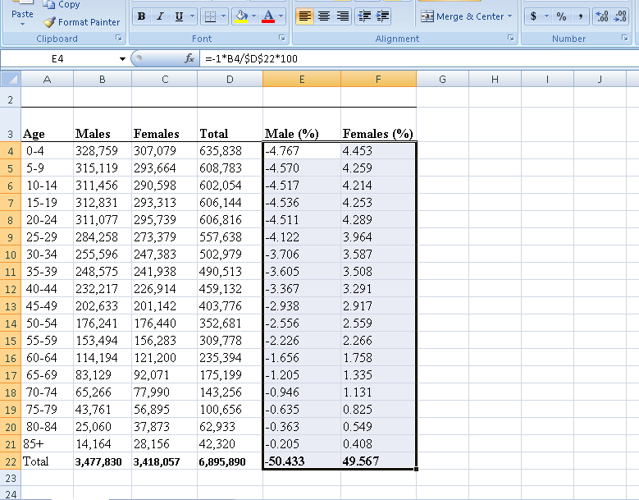

To build the population pyramid, we need to choose a horizontal bar chart with two series ofdata (% male and % female) and the age labels in column A as the Category X-axis labels. Highlight the range A3:A21, hold down the CTRL key and highlight the range E3:F21
Under inset tab, under horizontal bar charts select clustered bar chart

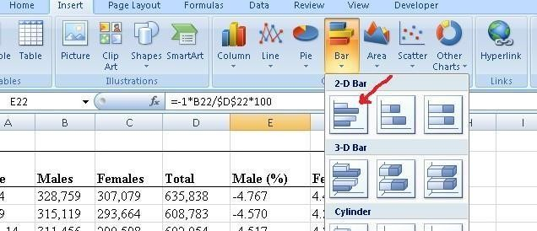

Put the tip of your mouse arrow on the Y-axis (vertical axis) so it says ―Category Axis‖, right click and chose Format Axis
Choose Axis options tab and set the major and minor tick mark type to None, Axis labels to
Low, and click OK.
Click on any of the bars in your pyramid, click right and select ―format data series‖. Set the
Overlap to 100 and Gap Width to 0. Click OK.
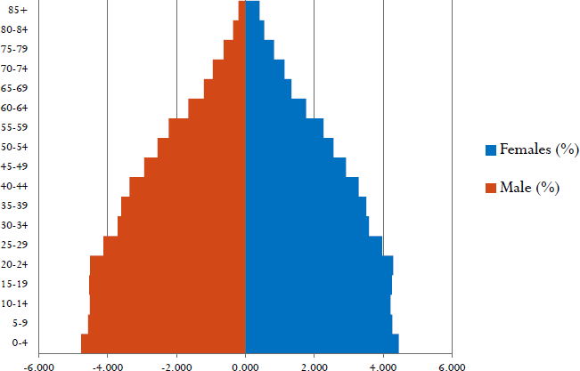

Practical 3

Perform testing of hypothesis using one sample t-test.
One sample t-test : The One Sample T Test determines whether the sample mean is statistically different from a known or hypothesised population mean. The One Sample T Test is a parametric test.

Program Code:
# -*- coding: utf-8 -*- fromscipy.stats import ttest_1sampimportnumpy as np ages = np.genfromtxt('ages.csv') print(ages)
ages_mean = np.mean(ages) print(ages_mean)
tset, pval = ttest_1samp(ages, 30)print('p- values - ',pval)

if pval< 0.05: # alpha value is 0.05
print(" we are rejecting null hypothesis")
else:
print("we are accepting null hypothesis")

Output:

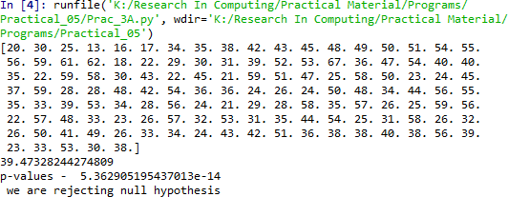

- Write a program for t-test comparing two means for independent samples.
The T distribution provides a good way to perform one sample tests on the mean when the population variance is not known provided the population is normal or the sample is sufficiently large so that the Central Limit Theorem applies.

Two Sample Test

Example: A college Principal informed classroom teachers that some of their students showed
Unusual potential for intellectual gains. One months later the students identified to teachers as having potential for unusual intellectual gains showed significantly greater gainsperformance on a test said to measure
IQ than did students who were not so identified. Below are the data for the students:

Experimental | Comparison
35 | 2
40 | 27
12 | 38
15 | 31
21 | 1
14 | 19
46 | 1
10 | 34
28 | 3
48 | 1
16 | 2
30 | 3
32 | 2
48 | 1
31 | 2
22 | 1
12 | 3
39 | 29
19 | 37
25 | 2
27.15 | 11.95 | Mean
12.51 | 14.61 | Sd

Experimental Data

To calculate Standard Mean go to cell A22 and type =SUM(A2:A21)/20
To calculate Standard Deviation go to cell A23 and type =STDEV(A2:A21) Comparison Data
To calculate Standard Mean go to cell B22 and type =SUM(B2:B21)/20

To calculate Standard Deviation go to cell B23 and type =STDEV(B2:B21) To find T- Test Statistics go to data Data Analysis


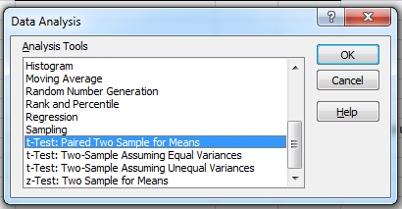

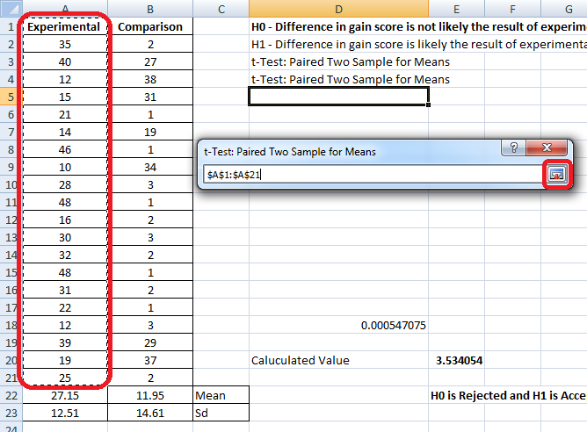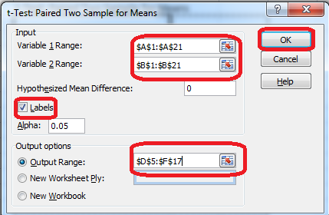

To caluculate the T-Test square value go to cell E20 and type
=(A22-B22)/SQRT((A23*A23)/COUNT(A2:A21)+(B23*B23)/COUNT(A2:A21))

Now go to cell E20 and type
=IF(E20<E12,"H0 is Accepted", "H0 is Rejected and H1 is Accepted")

Our calculated value is larger than the tabled value at alpha = .01, so we reject the null Hypothesis and accept the alternative hypothesis, namely, that the difference in gain scores is likely the resultof the experimental treatment and not the result of chance variation.

Output:
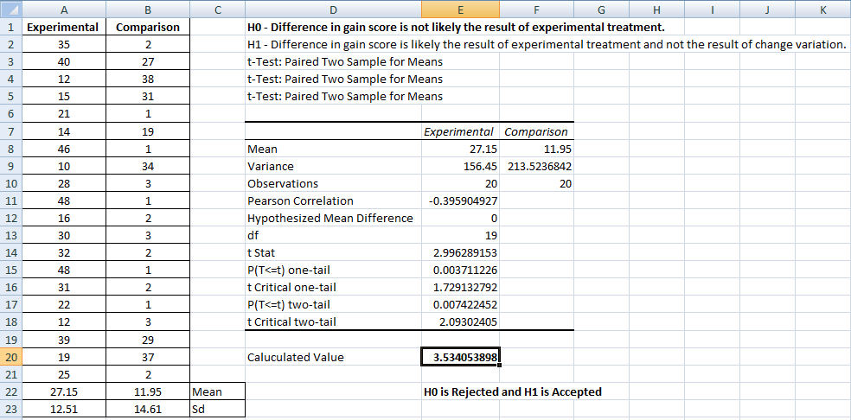
Using Python importnumpy as np fromscipy import stats
fromnumpy.random import randnN = 20
#a = [35,40,12,15,21,14,46,10,28,48,16,30, 32,48,31,22,12,39,19,25]
#b = [2,27,31,38,1,19,1,34,3,1,2,1,3,1,2,1,3,29,37,2]
a = 5 * randn(100) + 50b = 5 * randn(100) + 51var_a = a.var(ddof=1) var_b = b.var(ddof=1)
s = np.sqrt((var_a + var_b)/2)
t = (a.mean() - b.mean())/(s*np.sqrt(2/N))df = 2*N
- 2
#p-value after comparison with the tp = 1 - stats.t.cdf(t,df=df)
print("t = " + str(t)) print("p = "
+ str(2*p))if t> p :
print('Mean of two distribution are differnt and significant')else: print('Mean of two distribution are same and not significant')

Output:
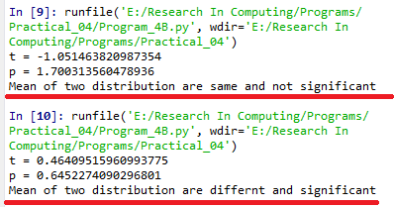

A. Perform testing of hypothesis using paired t-test.

The paired sample t-test is also called dependent sample t-test. It‘s an univariate test that tests fora significant difference between 2 related variables. An example of this is if you where t
collect the blood pressure for an individual before and after some treatment, condition, or time point. The data set contains blood pressure readings before and after an intervention. These are variables
―bp_before‖ and ―bp_after‖. The hypothesis being test is:
- H0 - The mean difference between sample 1 and sample 2 is equal to 0.
- H0 - The mean difference between sample 1 and sample 2 is not equal to 0

Program Code:
# -*- coding: utf-8 -*-
Created on Mon Dec 16 19:49:23 2019from scipy import stats
import matplotlib.pyplot as pltimport pandas as pd
df = pd.read_csv("blood_pressure.csv") print(df[['bp_before','bp_after']].describe())

#First let‘s check for any significant outliers in#each of the variables.
df[['bp_before', 'bp_after']].plot(kind='box')# This saves the plot as a png file plt.savefig('boxplot_outliers.png')

# make a histogram to differences between the two scores. df['bp_difference'] = df['bp_before'] - df['bp_after']

df['bp_difference'].plot(kind='hist', title= 'Blood Pressure Difference Histogram')#Again, this saves the plot as a png file
plt.savefig('blood pressure difference histogram.png') stats.probplot(df['bp_difference'], plot= plt) plt.title('Blood pressure Difference Q-Q Plot') plt.savefig('blood pressure difference qq plot.png') stats.shapiro(df['bp_difference']) stats.ttest_rel(df['bp_before'], df['bp_after'])

Output:

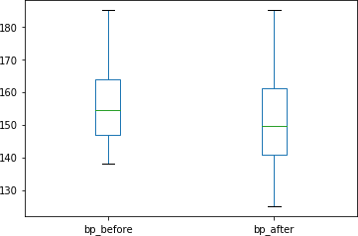
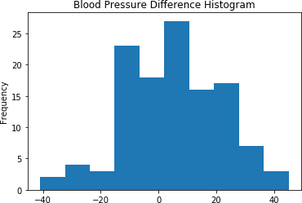

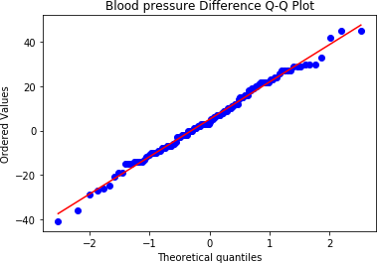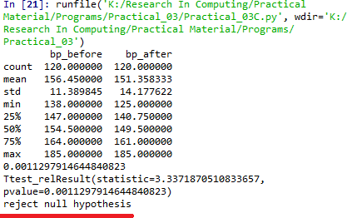

A paired sample t-test was used to analyze the blood pressure before and after the intervention to test if the intervention had a significant affect on the blood pressure. The blood pressure before the intervention was higher (156.45 ± 11.39 units) compared to the blood pressure postintervention (151.36 ± 14.18 units); there was a statistically significant decrease in blood pressure (t(119)=3.34, p= 0.0011) of 5.09 units.

Practical 4

Perform testing of hypothesis using chi-squared goodness-of-fit test. Problem

Ansystem administrator needs to upgrade the computers for his division. He wants to know what sort of computer system his workers prefer. He gives three choices: Windows, Mac, or Linux. Test the hypothesis or theory that an equal percentage ofthe population prefers each type of computer system .
System | O | Ei | 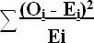
Windows | 20 | 33.33  %
Mac | 60 | 33.33  %
Linux | 20 | 33.33  %
H0 : The population distribution of the variable is the same as the proposed distribution HA : The distributions are different
To calculate the Chi –Squred value for Windows go to cell D2 and type =((B2-C2)*(B2- C2))/C2

To calculate the Chi –Squred value for Mac go to cell D3 and type =((B3-C3)*(B3-C3))/C3 To calculate the Chi –Squred value for Mac go to cell D3 and type =((B4-C4)*(B4-C4))/C4

Go to Cell D5 for and type=SUM(D2:D4)
To get the table value for Chi-Square for α = 0.05 and dof = 2, go to cell D7 and type
=CHIINV(0.05,2)
At cell D8 type =IF(D5>D7, "H0 Accepted","H0 Rejected")

Output:
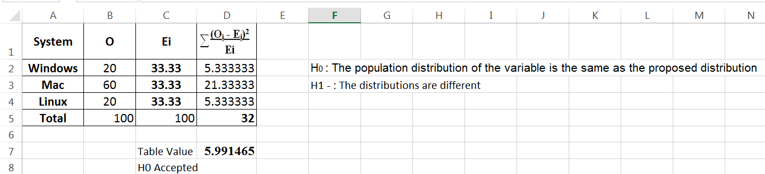

Perform testing of hypothesis using chi-squared test of independence.
In a study to understatnd the permormacne of M. Sc. IT Part -1 class, a college selects a randomsample of 100 students. Each student was asked his grade obtained in B. Sc. IT. The sampleisas given below

Sr. No
1
2
3
4
5
6
7
8
9
10
11
12
13
14
15
16
17
18
19
20
21
22
23
24
25
26
27
28
29
30
31
32
33
34
35
36
37
38
39
40
41
42
43
44
45
46
47
48
Roll No
Student's Name
Gen
Grade
1
2
5
13
16
17
34
35
38
42
43
45
48
49
50
51
54
55
56
59
61
62
65
66
68
69
70
85
87
88
6
12
15
19
27
28
37
44
57
60
63
64
71
86
18
22
29
30
Gaborone Francistown Niamey Maxixe Tema Kumasi Blida
Oran Saefda Constantine Annaba Bejaefa Medea Djelfa Tipaza Bechar
Mostaganem Tiaret Bouira Tebessa
El Harrach Mila Fouka
El Eulma SidiBel Abbes Jijel
Guelma
Khemis El Khechna Bordj El Kiffan Lakhdaria
Maputo Lichinga Ressano Garcia Accra
Wa Navrongo Mascara Batna
El Biar Boufarik OuedRhiou Souk Ahras Dar El Befda Birtouta Takoradi Cape Coast Kwabeng
Algiers
m m m m m m m m m m m m m m m m m m m m m m m m m m m m m m m m m m m m m m m m m m m m m m m
m
O O O O O O O O O O O O O O O O O O O O O O O O O O O O O O D D D D D D D D D D D D D D C C C
C
49
31
Laghouat
m
C
50
39
Relizane
m
C
51
52
Setif
m
C
52
53
Biskra
m
C
53
67
Kolea
m
C
54
100
AefnFakroun
m
C
55

56
26

32
Nima

TiziOuzou
m

m
B

B
57
33
Chlef
m
B
58
89
M'sila
m
A
59
96
Heliopolis
m
A
60
97
Berrouaghia
m
A
61
98
Sougueur
m
A
Sr. No | Roll No | Student's Name | Gen | Grade
62 | 3 | Maun | f | O
63 | 7 | Tete | f | O
64 | 9 | Chimoio | f | O
65 | 11 | Pemba | f | O
66 | 14 | Chibuto | f | O
67 | 25 | Mampong | f | O
68 | 36 | Tlemcen | f | O
69 | 40 | Adrar | f | O
70 | 41 | Tindouf | f | O
71 | 46 | Skikda | f | O
72 | 47 | Ouargla | f | O
73 | 10 | Matola | f | D
74 | 20 | Legon | f | D
75 | 21 | Sunyani | f | D
76 | 72 | Teenas | f | D
77 | 73 | Kouba | f | D
78 | 75 | HussenDey | f | D
79 | 77 | Khenchela | f | D
80 | 82 | HassiBahbah | f | D
81 | 84 | Baraki | f | D
82 | 91 | Boudouaou | f | D
83 | 95 | Tadjenanet | f | D
84 | 4 | Molepolole | f | C
85 | 8 | Quelimane | f | C
86 | 23 | Bolgatanga | f | C
87 | 58 | Mohammadia | f | C
88 | 83 | Merouana | f | C
89 | 24 | Ashaiman | f | B
90 | 76 | N'gaous | f | B
91 | 90 | Bab El Oued | f | B
92 | 92 | BordjMenael | f | B
93 | 93 | Ksar El Boukhari | f | B
94 | 74 | Reghaa | f | A
95 | 78 | Cheria | f | A
96 | 79 | Mouzaa | f | A
97 | 80 | Meskiana | f | A
98 | 81 | Miliana | f | A
99 | 94 | Sig | f | A
100 | 99 | Kadiria | f | A

Null Hypothesis - H0 : The performance of girls students is same as boys students. Alternate Hypothesis - H1 : The performance of boys and girls students are different. Open Excel Workbook

 | O | A | B | C | D | Total | 
Girls | 11 | 7 | 5 | 5 | 11 | 39 | 6.075
Boys | 30 | 4 | 3 | 10 | 14 | 61 | 6.075
Total | 41 | 11 | 8 | 15 | 25 | 100 | 12.150
Ei | 20.5 | 5.5 | 4 | 7.5 | 12.5 | 50

Prepare a contingency table as shown above. To calculate Girls Students with ‗O‘ Grade
Go to Cell N6 and type =COUNTIF($J$2:$K$40,"O")

To calculate Girls Students with ‗A‘ Grade
Go to Cell O6 and type =COUNTIF($J$2:$K$40,"A")

To calculate Girls Students with ‗B‘ Grade
Go to Cell P6 and type =COUNTIF($J$2:$K$40,"B")

To calculate Girls Students with ‗C‘ Grade
Go to Cell Q6 and type =COUNTIF($J$2:$K$40,"C")

To calculate Girls Students with ‗D‘ Grade
Go to Cell R6 and type =COUNTIF($J$2:$K$40,"D")

To calculate Boys Students with ‗O‘ Grade
Go to Cell N7 and type =COUNTIF($D$2:$E$62,"O") To calculate Boys Students with ‗A‘ Grade
Go to Cell O7 and type =COUNTIF($D$2:$E$62,"A") To calculate Boys Students with ‗B‘ Grade
Go to Cell P7 and type =COUNTIF($D$2:$E$62,"B") To calculate Boys Students with ‗C‘ Grade
Go to Cell Q7 and type =COUNTIF($D$2:$E$62,"C") To calculate Boys Students with ‗D‘ Grade
Go to Cell R7 and type =COUNTIF($D$2:$E$62,"D")

To calculated the expected value Ei
Go to Cell N9 and type =N8/2 Go to Cell O9 and type =O8/2 Go to Cell P9 and type =P8/2 Go to Cell Q9 and type =Q8/2 Go to Cell R9 and type =R8/2
Go to Cell S6 and calculate total girl students = SUM(N6:R6) Go to Cell S7 and calculate total girl students = SUM(N7:R7)

Now Calculate
Go to cell T6 and type
=SUM((N6-$N$9)^2/$N$9,(O6-$O$9)^2/$O$9,(P6-$P$9)^2/$P$9,(Q6-Q$9)^2/$Q$9, (R6-
$R$9)^2/$R$9)
Go to cell T7 and type
=SUM((N7-$N$9)^2/$N$9,(O7-$O$9)^2/$O$9,(P7-$P$9)^2/$P$9,(Q7-Q$9)^2/$Q$9, (R7-
$R$9)^2/$R$9)
To get the table value go to cell T11 and type =CHIINV(0.05,4)
Go to cell O13 and type =IF(T8>=T11," H0 is Accepted", "H0 is Rejected")

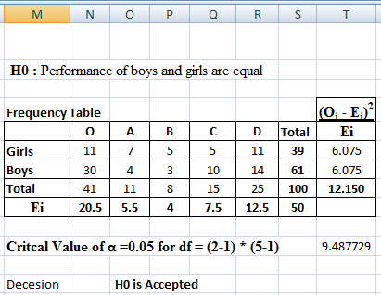

Using Python
importnumpy as np import pandas as pd importscipy.stats as statsnp.random.seed(10)
stud_grade = np.random.choice(a=["O","A","B","C","D"],
p=[0.20, 0.20 ,0.20, 0.20, 0.20], size=100)
stud_gen = np.random.choice(a=["Male","Female"], p=[0.5, 0.5], size=100)mscpart1
= pd.DataFrame({"Grades":stud_grade, "Gender":stud_gen}) print(mscpart1) stud_tab = pd.crosstab(mscpart1.Grades, mscpart1.Gender, margins=True)
stud_tab.columns = ["Male", "Female", "row_totals"] stud_tab.index = ["O", "A", "B", "C", "D", "col_totals"]observed
= stud_tab.iloc[0:5, 0:2 ] print(observed)
expected = np.outer(stud_tab["row_totals"][0:5], stud_tab.loc["col_totals"][0:2]) / 100 print(expected) chi_squared_stat = (((observed-expected)**2)/expected).sum().sum() print('Calculated : ',chi_squared_stat)

crit = stats.chi2.ppf(q=0.95, df=4) print('Table Value : ',crit)

ifchi_squared_stat>= crit:print('H0 is Accepted ') else:
print('H0 is Rejected ')

Output :

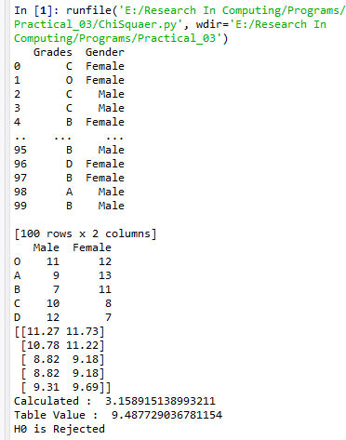

Practical 5

Perform testing of hypothesis using Z-test.
Use a Z test if:
- Your sample size is greater than 30. Otherwise, use a t test.
- Data points should be independent from each other. In other words, one data point isn‘trelated or doesn‘t affect another data point.
- Your data should be normally distributed. However, for large sample sizes (over 30)this doesn‘t always matter.
- Your data should be randomly selected from a population, where each item has an equalchance of being selected.
- Sample sizes should be equal if at all possible.
Ho - Blood pressure has a mean of 156 units

Program Code for one-sample Z test.
from statsmodels.stats import weightstats as stestsimport pandas as pd
from scipy import stats
df = pd.read_csv("blood_pressure.csv") df[['bp_before','bp_after']].describe() print(df)
ztest ,pval = stests.ztest(df['bp_before'], x2=None, value=156) print(float(pval))

if pval<0.05:
print("reject null hypothesis")else:
print("accept null hypothesis")

Output:
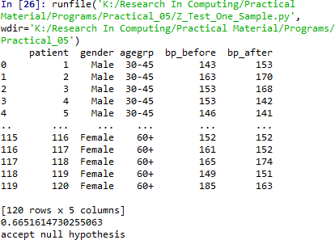

Two-sample Z test- In two sample z-test , similar to t-test here we are checking two independent data groups and deciding whether sample mean of two group is equal or not.

H0 : mean of two group is 0
H1 : mean of two group is not 0
# -*- coding: utf-8 -*- """

Created on Mon Dec 16 20:42:17 2019@author:
MyHome """

import pandas as pd
from statsmodels.stats import weightstats as stestsdf = pd.read_csv("blood_pressure.csv") df[['bp_before','bp_after']].describe()
print(df)

ztest ,pval = stests.ztest(df['bp_before'], x2=df['bp_after'], value=0,alternative='two-sided') print(float(pval))

if pval<0.05:
print("reject null hypothesis")else: print("accept null hypothesis")

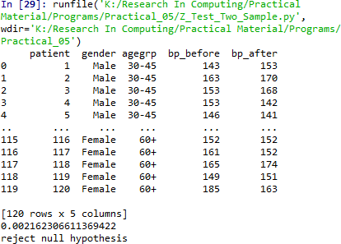

Practical 6

Perform testing of hypothesis using One-way ANOVA.
ANOVA ASSUMPTIONS
  - The dependent variable (SAT scores in our example) should be continuous.
  - The independent variables (districts in our example) should be two or more categorical groups.
  - There must be different participants in each group with no participant being in morethan one group. In our case, each school cannot be in more than one district.
  - The dependent variable should be approximately normally distributed for eachcategory.
  - Variances of each group are approximately equal.

From our data exploration, we can see that the average SAT scores are quite different foreach district. Since we have five different groups, we cannot use the t-test, use the 1-wayANOVA test anyway just to understand the concepts.

H0 - There are no significant differences between the groups' mean SATscores.
µ1 = µ2 = µ3 = µ4 = µ5

H1 - There is a significant difference between the groups' mean SATscores.
If there is at least one group with a significant difference with another group,the null hypothesis will be rejected.
import pandas as pd importnumpy as np importmatplotlib.pyplot as plt importseaborn as sns fromscipy import stats

data = pd.read_csv("scores.csv") data.head() data['Borough'].value_counts()

############### There is no total score column, have to create it. ########In addition, find the mean score of the each district across all
schools.

data['total_score'] = data['Average Score (SAT Reading)'] + \ data['Average Score (SAT Math)'] + \
data['Average Score (SAT Writing)']
data = data[['Borough', 'total_score']].dropna()
x = ['Brooklyn', 'Bronx', 'Manhattan', 'Queens', 'Staten Island']district_dict =
{}

#Assigns each test score series to a dictionary keyfor district in x:

district_dict[district] = data[data['Borough'] == district]['total_score']y = [] yerror = []
#Assigns the mean score and 95% confidence limit to each districtfor district in x:
y.append(district_dict[district].mean()) yerror.append(1.96*district_dict[district].std()/np.sqrt(district_dict[district].shap e[0])) print(district + '_std : {}'.format(district_dict[district].std()))

sns.set(font_scale=1.8)
fig = plt.figure(figsize=(10,5))
ax = sns.barplot(x, y, yerr=yerror) ax.set_ylabel('Average Total SAT Score') plt.show()

###################### Perform 1-way ANOVA

print(stats.f_oneway(
district_dict['Brooklyn'], district_dict['Bronx'], \ district_dict['Manhattan'], district_dict['Queens'], \ district_dict['Staten Island']
))
districts = ['Brooklyn', 'Bronx', 'Manhattan', 'Queens', 'Staten Island'] ss_b = 0
for d in districts:
ss_b += district_dict[d].shape[0] * \ np.sum((district_dict[d].mean() - data['total_score'].mean())**2) ss_w = 0
for d in districts:
ss_w += np.sum((district_dict[d] - district_dict[d].mean())**2) msb = ss_b/4
msw = ss_w/(len(data)-5) f=msb/msw
print('F_statistic: {}'.format(f))

ss_t = np.sum((data['total_score']-data['total_score'].mean())**2) eta_squared = ss_b/ss_t
print('eta_squared: {}'.format(eta_squared))

Output:

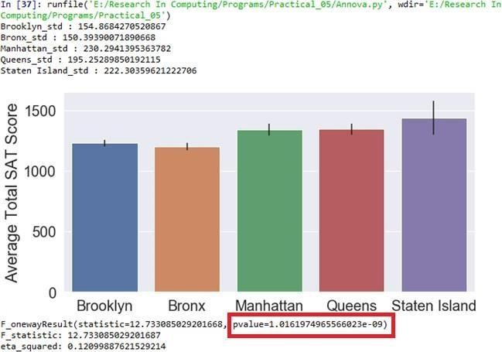

Since the resulting p value is less than 0.05. The null hypothesis is rejected and conclude thatthere is a significant difference between the SAT scores for each district.

Using Excel
H0 - There are no significant differences between the Subject’s mean SAT scores.
µ1 = µ2 = µ3 = µ4 = µ5

H1 - There is a significant difference between the Subject's mean SAT scores.



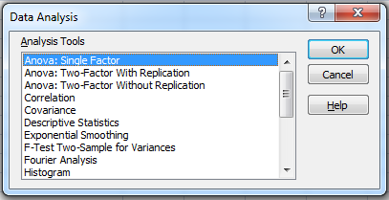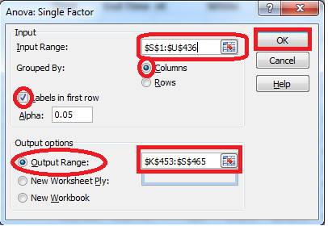

Input Range : $S$1:$U$436( Select columns to be analyzed in group)
Output Range :$K$453:$S$465( Can be any Range)

Anova: Single Factor
SUMMARY
Groups | Count | Sum | Average | Variance
Average Score (SAT Math) | 375 | 162354 | 432.944 | 5177.144
Average Score (SAT Reading) | 375 | 159189 | 424.504 | 3829.267
Average Score (SAT Writing) | 375 | 156922 | 418.4587 | 4166.522
ANOVA
Source of Variation | SS | df | MS | F | P-value | F crit
Between Groups | 39700.57 | 2 | 19850.28 | 4.520698 | 0.01108 | 3.003745
Within Groups | 4926677 | 1122 | 4390.977
Total | 4966377 | 1124

Since the resulting p value is less than 0.05. The null hypothesis (H0) is rejected and conclude at there is a significant difference between the SAT scores for each subject.

B:Perform testing of hypothesis using Two-way ANOVA.

Program Code:
import pandas as pd
import statsmodels.api as sm
from statsmodels.formula.api import ols
from statsmodels.stats.anova import anova_lm
from statsmodels.graphics.factorplots import interaction_plot import matplotlib.pyplot as plt
from scipy import stats

def eta_squared(aov):
aov['eta_sq'] = 'NaN'
aov['eta_sq'] = aov[:-1]['sum_sq']/sum(aov['sum_sq']) return aov

def omega_squared(aov):
mse = aov['sum_sq'][-1]/aov['df'][-1] aov['omega_sq'] = 'NaN'
aov['omega_sq'] = (aov[:-1]['sum_sq']-(aov[:-1]['df']*mse))/(sum(aov['sum_sq'])+mse) return aov

datafile = "ToothGrowth.csv" data = pd.read_csv(datafile)
fig = interaction_plot(data.dose, data.supp, data.len, colors=['red','blue'], markers=['D','^'], ms=10)
N = len(data.len)
df_a = len(data.supp.unique()) - 1 df_b = len(data.dose.unique()) - 1 df_axb = df_a*df_b
df_w = N - (len(data.supp.unique())*len(data.dose.unique())) grand_mean = data['len'].mean()
#Sum of Squares A – supp
ssq_a = sum([(data[data.supp ==l].len.mean()-grand_mean)**2 for l in data.supp]) #Sum of Squares B – supp
ssq_b = sum([(data[data.dose ==l].len.mean()-grand_mean)**2 for l in data.dose]) #Sum of Squares Total
ssq_t = sum((data.len - grand_mean)**2)vc
= data[data.supp == 'VC'] oj = data[data.supp == 'OJ']
vc_dose_means = [vc[vc.dose == d].len.mean() for d in vc.dose] oj_dose_means = [oj[oj.dose == d].len.mean() for d in oj.dose]
ssq_w = sum((oj.len - oj_dose_means)**2) +sum((vc.len - vc_dose_means)**2) ssq_axb = ssq_t-ssq_a-ssq_b-ssq_w
ms_a = ssq_a/df_a #Mean Square A ms_b = ssq_b/df_b #Mean Square B
ms_axb = ssq_axb/df_axb #Mean Square AXB ms_w = ssq_w/df_w
f_a = ms_a/ms_wf_b = ms_b/ms_w

f_axb = ms_axb/ms_w
p_a = stats.f.sf(f_a, df_a, df_w) p_b = stats.f.sf(f_b, df_b, df_w)
p_axb = stats.f.sf(f_axb, df_axb, df_w)
results = {'sum_sq':[ssq_a, ssq_b, ssq_axb, ssq_w], 'df':[df_a, df_b, df_axb, df_w],
'F':[f_a, f_b, f_axb, 'NaN'],
'PR(>F)':[p_a, p_b, p_axb, 'NaN']}
columns=['sum_sq', 'df', 'F', 'PR(>F)']

aov_table1 = pd.DataFrame(results, columns=columns, index=['supp', 'dose',
'supp:dose', 'Residual'])
formula = 'len ~ C(supp) + C(dose) + C(supp):C(dose)' model = ols(formula, data).fit()
aov_table = anova_lm(model, typ=2) eta_squared(aov_table) omega_squared(aov_table) print(aov_table.round(4))
res = model.resid
fig = sm.qqplot(res, line='s') plt.show()

Output:
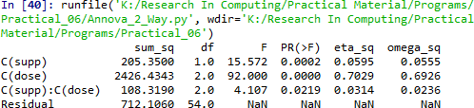

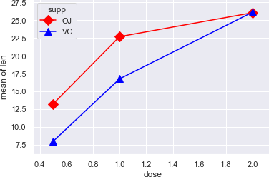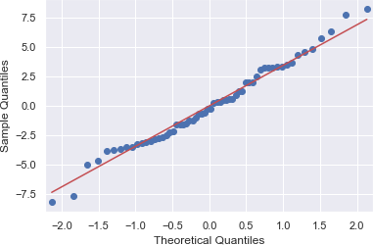

Using Excel:


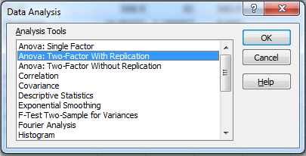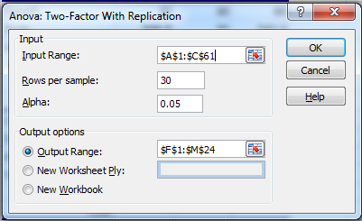

Input Range - $A$1:$C$61
Rows Per Sample – 30 (Beacause 30 Patients are given each dose) Alpha – 0.05
Output Range - $F$1:$M$24

Output:

Anova: Two-Factor With Replication
SUMMARY | len | dose | Total
1
Count | 30 | 30 | 60
Sum | 508.9 | 35 | 543.9
Average | 16.96333 | 1.166667 | 9.065
Variance | 68.32723 | 0.402299 | 97.22333
31
Count | 30 | 30 | 60
Sum | 619.9 | 35 | 654.9
Average | 20.66333 | 1.166667 | 10.915
Variance | 43.63344 | 0.402299 | 118.2854
Total
Count | 60 | 60
Sum | 1128.8 | 70
Average | 18.81333 | 1.166667
Variance | 58.51202 | 0.39548
ANOVA

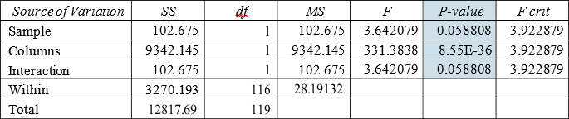

P-value = 0.0588079 columns in the ANOVA Source of Variation table at the bottom of the Output. Because the p- values for both medicine dose and interaction are less than our significance level, the factors are statistically significant. On the other hand, the interaction effect is not significant because its p-value (0.0588) is greater than our significance level. Because the interaction effect is not significant, we can focus on only the main effects and not consider the interaction effect of the dose.

Perform testing of hypothesis using MANOVA. Code:
import pandas as pd fromstatsmodels.multivariate.manova import MANOVA df = pd.read_csv('iris.csv', index_col=0)
df.columns = df.columns.str.replace(".", "_") df.head()
print('~~~~~~~~ Data Set ~~~~~~~~') print(df)
maov = MANOVA.from_formula('Sepal_Length + Sepal_Width + \ Petal_Length + Petal_Width ~ Species', data=df)
print('~~~~~~~~ MANOVA Test Result ~~~~~~~~') print(maov.mv_test())

Output:

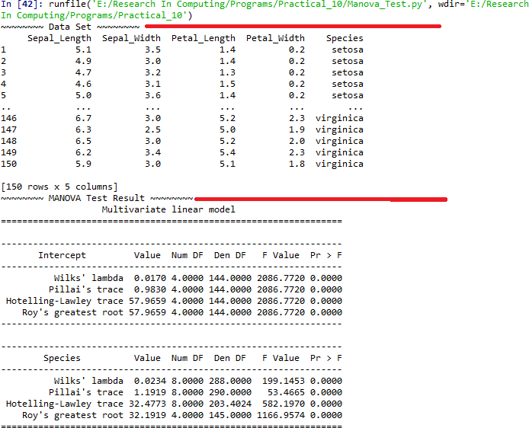

Practical 7

- Perform the Random sampling for the given data and analyse it. Example 1: From a population of 10 women and 10 men as given in the table in Figure 1 onthe left below, create a random sample of 6 people for Group 1 and a periodic sample consistingof every 3rd woman for Group 2. You need to run the sampling data analysis tool twice, once to create Group 1 and again to create Group
2. For Group 1 you select all 20 population cells as the Input Range and Randomas the Sampling Method with 6 for the Random Number of Samples. For Group 2 you select the 10 cells in the Women column as Input Range and Periodic with Period 3.
Open existing excel sheet with population dataSample Sheet looks as given below:
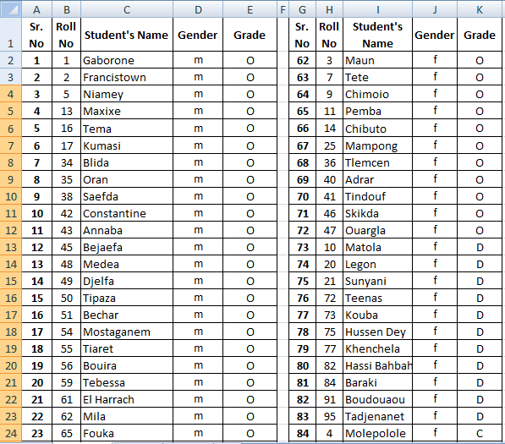

Output:
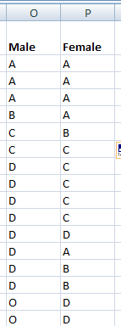

- Perform the Stratified sampling for the given data and analyse it.
we are to carry out a hypothetical housing quality survey across Lagos state, Nigeria. And we looking at a total of 5000 houses (hypothetically). We don‘t just go to one local government and select 5000 houses, rather we ensure that the 5000 houses are a representative of the whole20 local government areas Lagos state is comprised of. This is called stratified sampling. The population is divided into homogenous strata and the right number of instances is sampled fromeach stratum to guarantee that the test-set (which in this case is the 5000 houses) is a representative of the overall population. If we used random sampling, there would be a significant chance of having bias in the survey results.

Program Code:
import pandas as pd importnumpy as np

importmatplotlib importmatplotlib.pyplot as plt

plt.rcParams['axes.labelsize'] = 14
plt.rcParams['xtick.labelsize'] = 12
plt.rcParams['ytick.labelsize'] = 12

importseaborn as sns color = sns.color_palette() sns.set_style('darkgrid')

importsklearn
fromsklearn.model_selection import train_test_split

housing =pd.read_csv('housing.csv') print(housing.head()) print(housing.info())

#creating a heatmap of the attributes in the dataset correlation_matrix = housing.corr() plt.subplots(figsize=(8,6))
sns.heatmap(correlation_matrix, center=0, annot=True, linewidths=.3)

corr =housing.corr() print(corr['median_house_value'].sort_values(ascending=False))

sns.distplot(housing.median_income)plt.show()

Output:
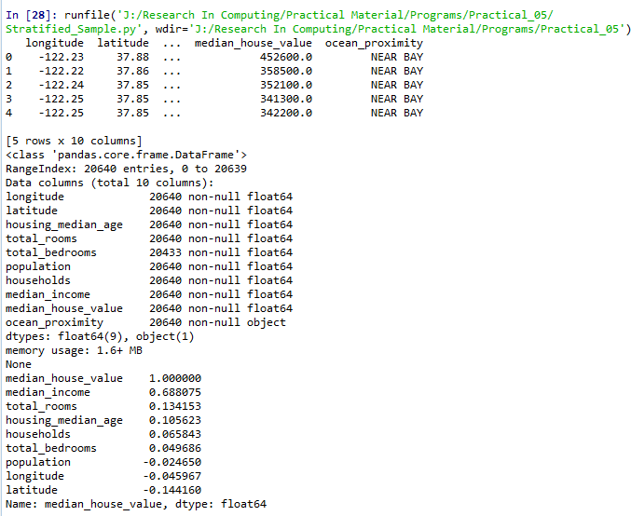
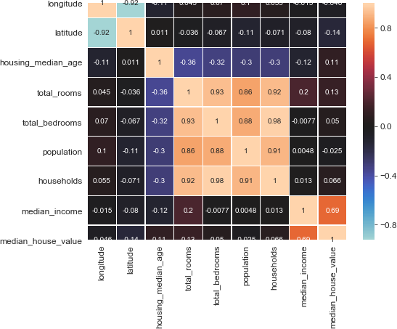

There‘s a ton of information we can mine from the heatmap above, a couple of strongly positively correlated features and a couple of negatively correlated features. Take a look at the small bright box right in the middle of the heatmap from total_rooms on the left ‘y-axis‘ till households and note how bright the box is as well as the highly positively correlated attributes, also note that median_income is the most correlated feature to the target which is median_house_value.

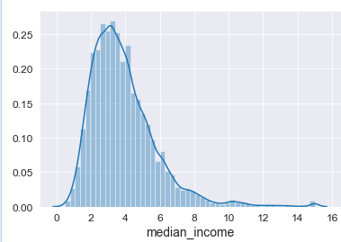

From the image above, we can see that most median incomes are clustered between
$20,000 and $50,000 with some outliers going far beyond $60,000 making the distribution skew to the right.

Practical 8

Write a program for computing different correlation.
Positive Correlation:

Code:
importnumpy as np importmatplotlib.pyplot as plt np.random.seed(1)
# 1000 random integers between 0 and 50
x = np.random.randint(0, 50, 1000)
# Positive Correlation with some noisey = x + np.random.normal(0, 10, 1000) np.corrcoef(x, y)
matplotlib.style.use('ggplot') plt.scatter(x, y)
plt.show()

Output:
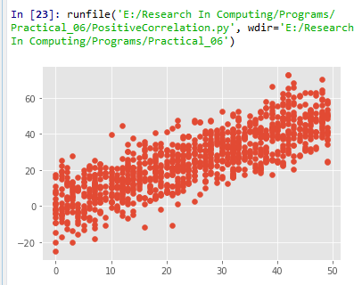

Negative Correlation:
import numpy as np
import matplotlib.pyplot as plt
np.random.seed(1)
# 1000 random integers between 0 and 50
x = np.random.randint(0, 50, 1000)
# Negative Correlation with some noise y = 100 - x + np.random.normal(0, 5, 1000)np.corrcoef(x, y)
plt.scatter(x, y)plt.show()

Output:
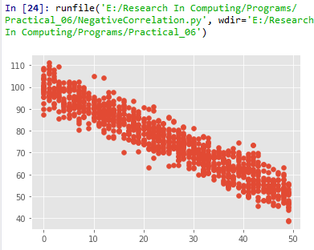

No/Weak Correlation: importnumpy as np importmatplotlib.pyplot as plt np.random.seed(1)
x = np.random.randint(0, 50, 1000)
y = np.random.randint(0, 50, 1000) np.corrcoef(x, y)
plt.scatter(x, y) plt.show()

Output:
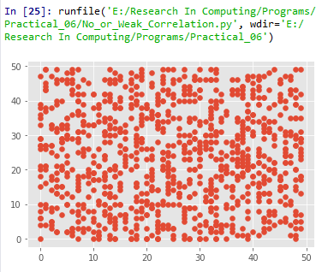

Practical 9

Write a program to Perform linear regression for prediction.
# -*- coding: utf-8 -*- import Quandl, math import numpy as np import pandas as pd
from sklearn import preprocessing, cross_validation, svm from sklearn.linear_model import LinearRegression import matplotlib.pyplot as plt
from matplotlib import style import datetime style.use('ggplot')
df = Quandl.get("WIKI/GOOGL")
df = df[['Adj. Open', 'Adj. High', 'Adj. Low', 'Adj. Close', 'Adj. Volume']]
df['HL_PCT'] = (df['Adj. High'] - df['Adj. Low']) / df['Adj. Close'] * 100.0
df['PCT_change'] = (df['Adj. Close'] - df['Adj. Open']) / df['Adj. Open'] * 100.0

df = df[['Adj. Close', 'HL_PCT', 'PCT_change', 'Adj. Volume']] forecast_col = 'Adj. Close'
df.fillna(value=-99999, inplace=True) forecast_out = int(math.ceil(0.01 * len(df))) df['label'] = df[forecast_col].shift(-forecast_out)

X = np.array(df.drop(['label'], 1))X
= preprocessing.scale(X) X_lately
= X[-forecast_out:] X = X[:-forecast_out]

df.dropna(inplace=True)y
= np.array(df['label'])
X_train, X_test, y_train, y_test = cross_validation.train_test_split(X, y, test_size=0.2)clf
= LinearRegression(n_jobs=-1) clf.fit(X_train, y_train)
confidence = clf.score(X_test, y_test)

forecast_set = clf.predict(X_lately) df['Forecast'] = np.nan

last_date = df.iloc[-1].name last_unix = last_date.timestamp() one_day = 86400
next_unix = last_unix + one_day

for i in forecast_set:
next_date = datetime.datetime.fromtimestamp(next_unix) next_unix += 86400
df.loc[next_date] = [np.nan for _ in range(len(df.columns)-1)]+[i] df['Adj. Close'].plot()

df['Forecast'].plot() plt.legend(loc=4) plt.xlabel('Date') plt.ylabel('Price') plt.show()

Output:
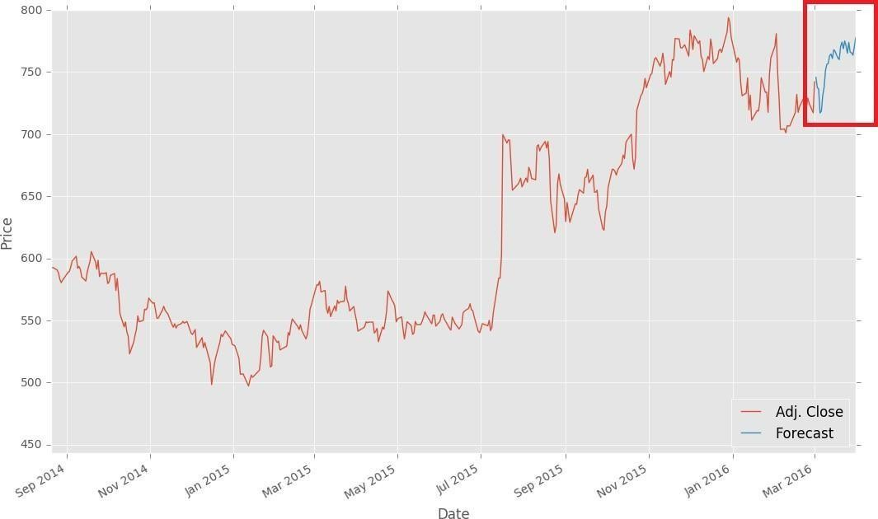

Perform polynomial regression for prediction.
importnumpy as np importmatplotlib.pyplot as plt

defestimate_coef(x, y):
# number of observations/pointsn = np.size(x)

# mean of x and y vector
m_x, m_y = np.mean(x), np.mean(y)

# calculating cross-deviation and deviation about xSS_xy = np.sum(y*x) - n*m_y*m_x
SS_xx = np.sum(x*x) - n*m_x*m_x

# calculating regression coefficientsb_1 =
SS_xy / SS_xx
b_0 = m_y - b_1*m_x return(b_0, b_1)
defplot_regression_line(x, y, b):
# plotting the actual points as scatter plot plt.scatter(x, y, color = "m",
marker = "o", s = 30)

# predicted response vectory_pred = b[0] + b[1]*x

# plotting the regression line plt.plot(x, y_pred, color = "g")

# putting labels plt.xlabel('x')
plt.ylabel('y')

# function to show plot plt.show()

def main():
# observations
x = np.array([0, 1, 2, 3, 4, 5, 6, 7, 8, 9])
y = np.array([1, 3, 2, 5, 7, 8, 8, 9, 10, 12])

# estimating coefficientsb = estimate_coef(x, y)
print("Estimated coefficients:\nb_0 = {} b_1 = {}".format(b[0], b[1]))

# plotting regression line plot_regression_line(x, y, b)

if name == " main ":main()

Output:
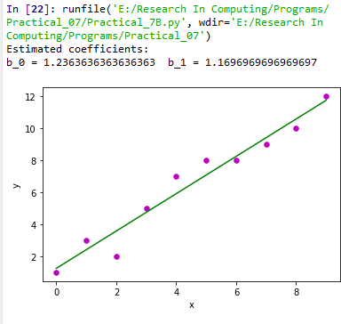

Practical 10

Write a program for multiple linear regression analysis.
Step #1: Data Pre Processing
  - Importing The Libraries.
  - Importing the Data Set.
  - Encoding the Categorical Data.
  - Avoiding the Dummy Variable Trap.
  - Splitting the Data set into Training Set and Test Set.Step #2: Fitting Multiple Linear Regression to the Training setStep #3: Predicting the Test set results.
importnumpy as np importmatplotlib as mpl
from mpl_toolkits.mplot3d import Axes3D importmatplotlib.pyplot as plt defgenerate_dataset(n):
x = []
y = []
random_x1 = np.random.rand() random_x2 = np.random.rand() fori in range(n):
x1 = i
x2 = i/2 + np.random.rand()*n x.append([1, x1, x2])
y.append(random_x1 * x1 + random_x2 * x2 + 1) returnnp.array(x), np.array(y)
x, y = generate_dataset(200) mpl.rcParams['legend.fontsize'] = 12fig = plt.figure()
ax = fig.gca(projection ='3d')
ax.scatter(x[:, 1], x[:, 2], y, label ='y', s = 5) ax.legend()
ax.view_init(45, 0) plt.show() defmse(coef, x, y):
returnnp.mean((np.dot(x, coef) - y)**2)/2def gradients(coef, x, y):
returnnp.mean(x.transpose()*(np.dot(x, coef) - y), axis = 1) defmultilinear_regression(coef, x, y, lr, b1 = 0.9, b2 = 0.999, epsilon = 1e-8):
prev_error = 0
m_coef = np.zeros(coef.shape)v_coef = np.zeros(coef.shape)
moment_m_coef = np.zeros(coef.shape) moment_v_coef = np.zeros(coef.shape)t = 0 while True:
error = mse(coef, x, y)
if abs(error - prev_error) <= epsilon:break prev_error = error

grad = gradients(coef, x, y)t += 1
m_coef = b1 * m_coef + (1-b1)*grad v_coef = b2 * v_coef + (1-b2)*grad**2moment_m_coef = m_coef / (1-b1**t) moment_v_coef = v_coef / (1-b2**t)

delta = ((lr / moment_v_coef**0.5 + 1e-8) *
(b1 * moment_m_coef + (1-b1)*grad/(1-b1**t)))coef = np.subtract(coef, delta)
returncoef
coef = np.array([0, 0, 0])
c = multilinear_regression(coef, x, y, 1e-1)fig = plt.figure()
ax = fig.gca(projection ='3d') ax.scatter(x[:, 1], x[:, 2], y, label ='y',
s = 5, color ="dodgerblue") ax.scatter(x[:, 1], x[:, 2], c[0] + c[1]*x[:, 1] + c[2]*x[:, 2],
label ='regression', s = 5, color ="orange")
ax.view_init(45, 0) ax.legend() plt.show()

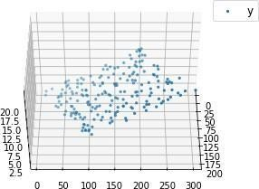
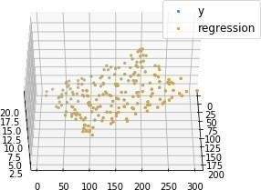
Output:

Perform logistic regression analysis.
Logistic regression is a classification method built on the same concept as linear regression. With linear regression, we take linear combination of explanatory variables plus an interceptterm to arrive at a prediction.
In this example we will use a logistic regression model to predict survival.

Program Code:
import os
import numpy as np import pandas as pd import matplotlib
import matplotlib.pyplot as pltimport scipy.stats as stats
from sklearn import linear_model from sklearn import preprocessingfrom sklearn import metrics

matplotlib.style.use('ggplot') plt.figure(figsize=(9,9))

def sigmoid(t): # Define the sigmoid functionreturn (1/(1 + np.e**(-t)))

plot_range = np.arange(-6, 6, 0.1)y_values

= sigmoid(plot_range) # Plot curve plt.plot(plot_range, # X-axis range
y_values, # Predicted values
color="red")
titanic_train = pd.read_csv("titanic_train.csv") # Read the data char_cabin = titanic_train["Cabin"].astype(str) # Convert cabin to str new_Cabin
= np.array([cabin[0] for cabin in char_cabin]) # Take first letter
titanic_train["Cabin"] = pd.Categorical(new_Cabin) # Save the new cabin var# Impute median Age for NA Age values
new_age_var = np.where(titanic_train["Age"].isnull(), # Logical check28, # Value if check is true titanic_train["Age"]) # Value if check is false

titanic_train["Age"] = new_age_var label_encoder =
preprocessing.LabelEncoder()# Convert Sex variable to numeric
encoded_sex = label_encoder.fit_transform(titanic_train["Sex"])

# Initialize logistic regression model
log_model = linear_model.LogisticRegression()

# Train the model
log_model.fit(X = pd.DataFrame(encoded_sex),y = titanic_train["Survived"])

# Check trained model intercept print(log_model.intercept_)

# Check trained model coefficients print(log_model.coef_)

# Make predictions
preds = log_model.predict_proba(X= pd.DataFrame(encoded_sex))preds = pd.DataFrame(preds)
preds.columns = ["Death_prob", "Survival_prob"]

# Generate table of predictions vs Sex pd.crosstab(titanic_train["Sex"], preds.ix[:, "Survival_prob"])

# Convert more variables to numeric
encoded_class = label_encoder.fit_transform(titanic_train["Pclass"]) encoded_cabin = label_encoder.fit_transform(titanic_train["Cabin"])

train_features = pd.DataFrame([encoded_class,
encoded_cabin, encoded_sex, titanic_train["Age"]]).T

# Initialize logistic regression model
log_model = linear_model.LogisticRegression()

# Train the model log_model.fit(X = train_features ,
y = titanic_train["Survived"])

# Check trained model intercept print(log_model.intercept_)

# Check trained model coefficients print(log_model.coef_)

# Make predictions
preds = log_model.predict(X= train_features)
# Generate table of predictions vs actual pd.crosstab(preds,titanic_train["Survived"]) log_model.score(X = train_features ,
y = titanic_train["Survived"])

metrics.confusion_matrix(y_true=titanic_train["Survived"], # True labels y_pred=preds) # Predicted labels

# View summary of common classification metrics print(metrics.classification_report(y_true=titanic_train["Survived"],
y_pred=preds) )

# Read and prepare test data
titanic_test = pd.read_csv("titanic_test.csv") # Read the data char_cabin = titanic_test["Cabin"].astype(str) # Convert cabin to str new_Cabin = np.array([cabin[0] for cabin in char_cabin]) # Take first letter
titanic_test["Cabin"] = pd.Categorical(new_Cabin) # Save the new cabin var# Impute

median Age for NA Age values
new_age_var = np.where(titanic_test["Age"].isnull(), # Logical check28, # Value if check is true titanic_test["Age"]) # Value if check is false

titanic_test["Age"] = new_age_var

# Convert test variables to match model features
encoded_sex = label_encoder.fit_transform(titanic_test["Sex"]) encoded_class = label_encoder.fit_transform(titanic_test["Pclass"]) encoded_cabin = label_encoder.fit_transform(titanic_test["Cabin"])

test_features = pd.DataFrame([encoded_class,
encoded_cabin,encoded_sex,titanic_test["Age"]]).T

# Make test set predictions
test_preds = log_model.predict(X=test_features)

# Create a submission for Kaggle
submission = pd.DataFrame({"PassengerId":titanic_test["PassengerId"], "Survived":test_preds})

# Save submission to CSV submission.to_csv("tutorial_logreg_submission.csv", index=False) # Do not save index values

print(pd)

Output:
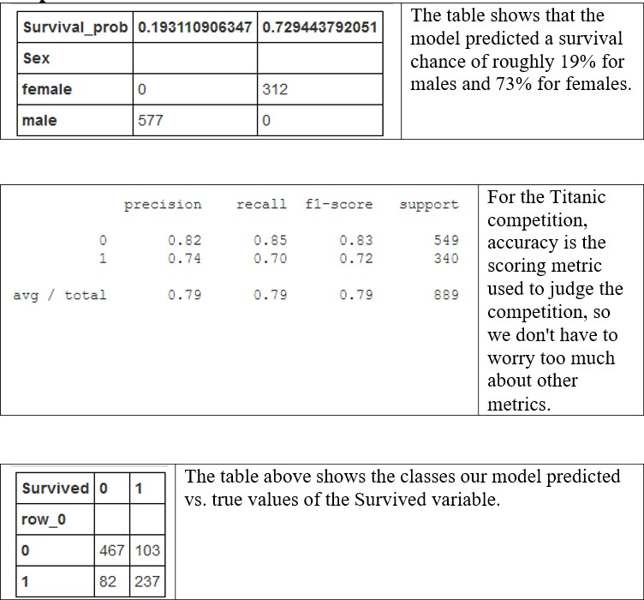
This logistic regression model has an accuracy score of 0.75598 which is actually worse thanthe accuracy of the simplistic women survive, men die model (0.76555).

Example 2:
The dataset is related to direct marketing campaigns (phone calls) of a Portuguese banking institution. The classification goal is to predict whether the client will subscribe (1/0) to a termdeposit (variable y). The dataset provides the bank customers‘ information. It includes 41,188records and 21 fields.

Input variables

- age (numeric)
- job : type of job (categorical: ―admin‖, ―blue-collar‖, ―entrepreneur‖, ―housemaid‖,
―management‖, ―retired‖, ―self-employed‖, ―services‖, ―student‖, ―technician‖,
―unemployed‖, ―unknown‖)
- marital : marital status (categorical: ―divorced‖, ―married‖, ―single‖, ―unknown‖)

- education (categorical: ―basic.4y‖, ―basic.6y‖, ―basic.9y‖, ―high.school‖, ―illiterate‖,
―professional.course‖, ―university.degree‖, ―unknown‖)
- default: has credit in default? (categorical: ―no‖, ―yes‖, ―unknown‖)
- housing: has housing loan? (categorical: ―no‖, ―yes‖, ―unknown‖)
- loan: has personal loan? (categorical: ―no‖, ―yes‖, ―unknown‖)
- contact: contact communication type (categorical: ―cellular‖, ―telephone‖)
- month: last contact month of year (categorical: ―jan‖, ―feb‖, ―mar‖, …, ―nov‖, ―dec‖)
- day_of_week: last contact day of the week (categorical: ―mon‖, ―tue‖, ―wed‖, ―thu‖,
―fri‖)
- duration: last contact duration, in seconds (numeric). Important note: this attribute highly affects the output target (e.g., if duration=0 then y=‘no‘). The duration is not known before a call is performed, also, after the end of the call, y is obviously known.Thus, this input should only be included for benchmark purposes and should be discarded if the intention is to have a realistic predictive model
- campaign: number of contacts performed during this campaign and for this client (numeric, includes last contact)
- pdays: number of days that passed by after the client was last contacted from a previous campaign (numeric; 999 means client was not previously contacted)
- previous: number of contacts performed before this campaign and for this client (numeric)
- poutcome: outcome of the previous marketing campaign (categorical: ―failure‖,
―nonexistent‖, ―success‖)
- emp.var.rate: employment variation rate — (numeric)
- cons.price.idx: consumer price index — (numeric)
- cons.conf.idx: consumer confidence index — (numeric)
- euribor3m: euribor 3 month rate — (numeric)
- nr.employed: number of employees — (numeric)

Predict variable (desired target):
y — has the client subscribed a term deposit?(binary:

―1‖, means ―Yes‖, ―0‖ means ―No‖)

Program Code: # -*- coding: utf-8 -*- import pandas as pd import numpy as np
from sklearn import preprocessing import matplotlib.pyplot as plt plt.rc("font", size=14)
from sklearn.linear_model import LogisticRegression from sklearn.model_selection import train_test_split import seaborn as sns
sns.set(style="white") sns.set(style="whitegrid", color_codes=True) data = pd.read_csv('bank.csv', header=0) data = data.dropna()
print(data.shape) print(list(data.columns)) data['education'].unique()
data['education']=np.where(data['education'] =='basic.9y', 'Basic', data['education']) data['education']=np.where(data['education'] =='basic.6y', 'Basic', data['education']) data['education']=np.where(data['education'] =='basic.4y', 'Basic', data['education']) data['education'].unique()
data['y'].value_counts()

sns.countplot(x='y', data=data, palette='hls') plt.show();
plt.savefig('Practical10B-plot.jpeg')

count_no_sub = len(data[data['y']==0]) count_sub = len(data[data['y']==1])
pct_of_no_sub = count_no_sub/(count_no_sub+count_sub) print("percentage of no subscription is", pct_of_no_sub*100) pct_of_sub = count_sub/(count_no_sub+count_sub) print("percentage of subscription", pct_of_sub*100)

data.groupby('y').mean()
data.groupby('job').mean() data.groupby('marital').mean() data.groupby('education').mean()

########### Purchase Frequency for Job Title pd.crosstab(data.job,data.y).plot(kind='bar') plt.title('Purchase Frequency for Job Title') plt.xlabel('Job')
plt.ylabel('Frequency of Purchase') plt.savefig('purchase_fre_job')

###################### Marital Status vs Purchase table=pd.crosstab(data.marital,data.y)
table.div(table.sum(1).astype(float), axis=0).plot(kind='bar', stacked=True) plt.title('Stacked Bar Chart of Marital Status vs Purchase') plt.xlabel('Marital Status')
plt.ylabel('Proportion of Customers') plt.savefig('mariral_vs_pur_stack')

############ Education vs Purchase table=pd.crosstab(data.education,data.y) table.div(table.sum(1).astype(float), axis=0).plot(kind='bar', stacked=True)plt.title('Stacked Bar Chart of Education vs Purchase') plt.xlabel('Education')
plt.ylabel('Proportion of Customers') plt.savefig('edu_vs_pur_stack')

pd.crosstab(data.day_of_week,data.y).plot(kind='bar') plt.title('Purchase Frequency for Day of Week') plt.xlabel('Day of Week')
plt.ylabel('Frequency of Purchase')plt.savefig('pur_dayofweek_bar')
########## Purchase Frequency for Month pd.crosstab(data.month,data.y).plot(kind='bar') plt.title('Purchase Frequency for Month') plt.xlabel('Month')
plt.ylabel('Frequency of Purchase') plt.savefig('pur_fre_month_bar')

############# Age Purchase frequency pattern data.age.hist()
plt.title('Histogram of Age') plt.xlabel('Age') plt.ylabel('Frequency') plt.savefig('hist_age')

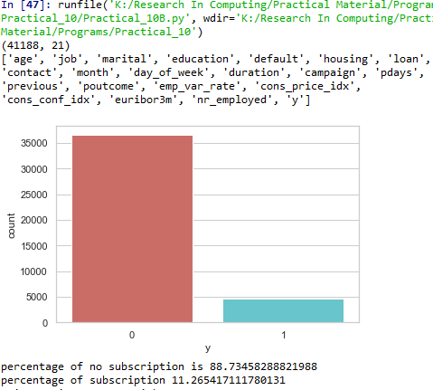Output: -
11.265417111780131
Our classes are imbalanced, and the ratio of no-subscription to subscription instances is 89:11.
- The average age of customers who bought the term deposit is higher thanthat of the customers who
didn‘t.
- The pdays (days since the customer waslast contacted) is understandably lower for the customers who bought it. The lower the pdays, the better the memory of the last call and hence the
SUBSCRIPTION
OF
PERCENTAGE
PERCENTAGE OF NO
SUBSCRIPTION IS 88.73458288821988

